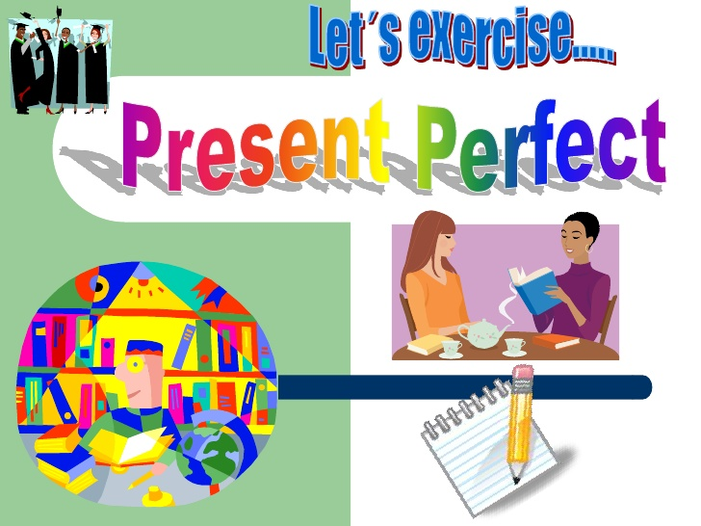
PRESENT PERFECT SIMPLE (test)
1) Write the past participle of the verbs.
1. carry______________
2. go ______________
3. break ______________
4. catch ______________
5. choose ______________
6. keep ______________
7. draw ______________
8. teach ______________
9. write ______________ 9

have/has + V-3/V-ed
have/has + V-3/V-ed

2) Underline the correct words in italics.
1. Sarah has/have never tasted Japanese food.
2. I haven’t live/lived in the city before now.
3. Have your parents ever visited Spain? Yes, they do/have.
4. Have/Has Mary ever stayed in any hotels? Yes, several times.
5. Has Sam ever played golf? No, he hasn’t/doesn’t. 5

3) Fill in the gaps with the verbs in the present perfect.
1. My friend Ted _____________ (spend) a lot of money on gadgets.
2. My father _______________ (not/buy) a new car.
3. The students _______________ (write) a lot of tests this term.
4. I _____________________ (travel) a lot.
5. They ___________________ (not/have) lunch this morning. 5
5

4) Choose been or gone.
1. ‘Where is Pamela?’ ‘She’s been/gone home.
2. ‘Do you like Berlin?’ ‘Yes. I’ve been/gone there twice and I love it.’
3. Jane’s been/gone to the dentist and now she’s going shopping.
4. Nick and Ann aren’t here. They’ve been/gone to the cinema.
5. Alan’s been/gone at the gym. He feels exhausted. 5

5) Complete the sentences. Use for or since.
1. We haven’t watched TV __________ Monday.
2. The boy hasn’t eaten anything ______ six hours.
3. I’ve known Pam ___________ primary school.
4. What have you done ______you finished school?
5. We have studied Chinese ______ three years. 5
6) Make questions using these words.
1. you / visited / Have / ever / Paris ?
_________________________________
2. your dad / ever / Has / anything / invented ?
__________________________________________________________________
3. watched / the best / What’s / you / have / film / ever ?
__________________________________________________________________
4. lived / Jeremy / in / How long / has / Oxford ?
__________________________________________________________________
5. you / the most / book / interesting / have / ever / What’s / read ?
__________________________________________________________________
1010

7) Choose just, yet or already.
1. He is here now. He has just/already/yet arrived.
2. Has Paul started his new job just/already/yet?
3. Their plane has not landed just/already/yet?
4. Ned has just/already/yet fed his pets.
5. Her hair’s wet. She’s just/already/yet washed it.
6. They have just/already/yet visited a lot of countries.
6

Total: 45

